Assignment1  
Name - Bhumika Punjabi, NUID- 001061256

# Architecture

**DataPipeline using Apache Beam and Google Cloud DataFlow as Runner and BigQuery as DataSink**

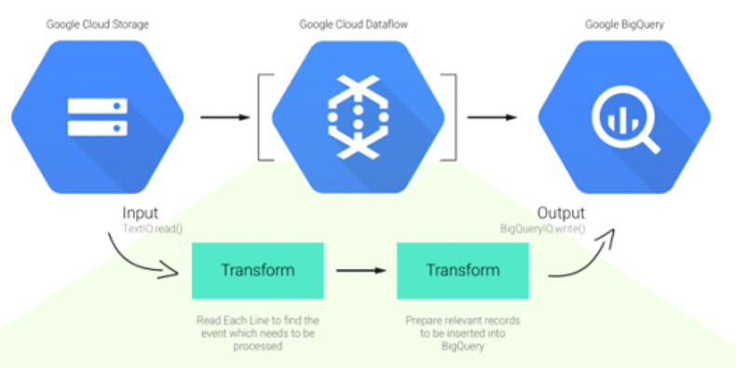

## The Anatomy of a Data Pipeline-

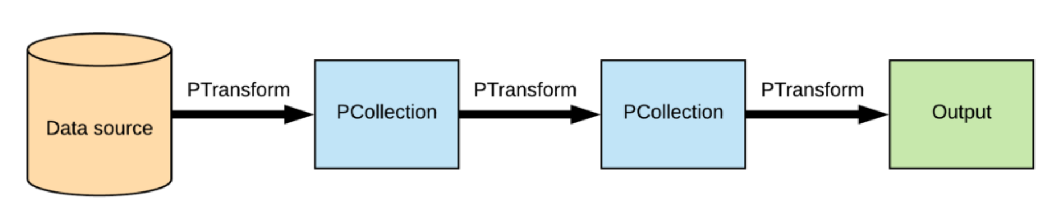

**Pipeline**: It encapsulates the data-processing tasks from start to end which includes reading I/P data, transforming and writing O/P data.

**PCollection**: A distributed dataset on which beam pipeline operates. It can be either bounded or unbounded. It is immutable in nature and thus, any transformation on PCollection will create a new PCollection.

**PTransform**: It represents data processing operations or transformation steps that are applied on PCollection.

**I/O Sink & Sources:** The Source and Sink APIs provide functions to read data into or write out of collections.

Commonly used Ptransforms below,used some of them in pipeline

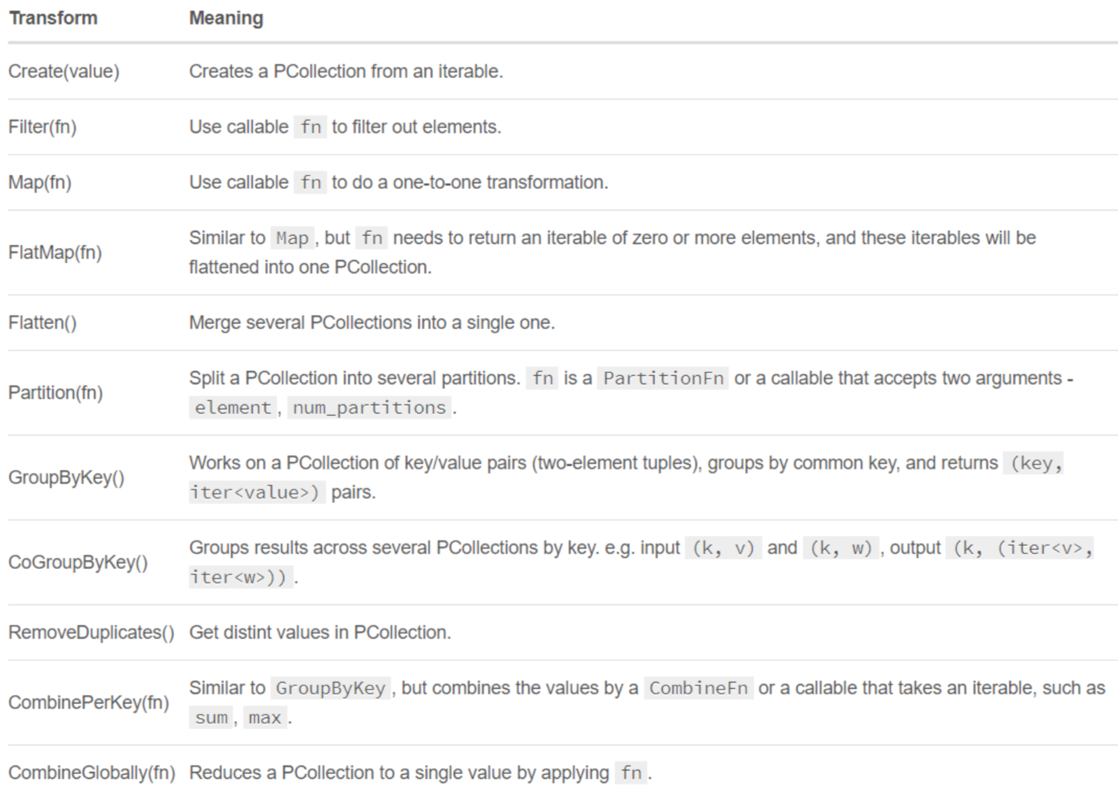

**ParDo** is a primary beam transform for generic parallel processing which is not in the above image. The ParDo processing paradigm is similar to the “Map” phase of a Map/Shuffle/Reduce-style algorithm: a ParDo transform considers each element in the input PCollection, performs some processing on that element, and emits zero, or multiple elements to an output PCollection.

**Pipe ‘|’** is the operator to apply transforms, and each transform can be optionally supplied with a unique label. Transforms can be chained, and we can compose arbitrary shapes of transforms, and at runtime, they’ll be represented as DAG.

# Flow of the pipeline

Developed a data pipeline to ingest, process, store it so as to access it using [Python SDK](https://beam.apache.org/get-started/quickstart-py/) and Cloud Dataflow to run the pipeline-

* Reads the data from google cloud storage bucket (Batch).
* Apply some transformations such as splitting data by comma separator, dropping unwanted columns, converting data types, etc.
* Write the data into data Sink (BigQuery)
* Joins Bigquery tables using reusable Composite Transforms
* Analyze it using Data studio.

1. Created cloud storage bucket and uploaded dataset to google cloud bucket-

Dataflow uses cloud bucket as a staging location to store temporary files

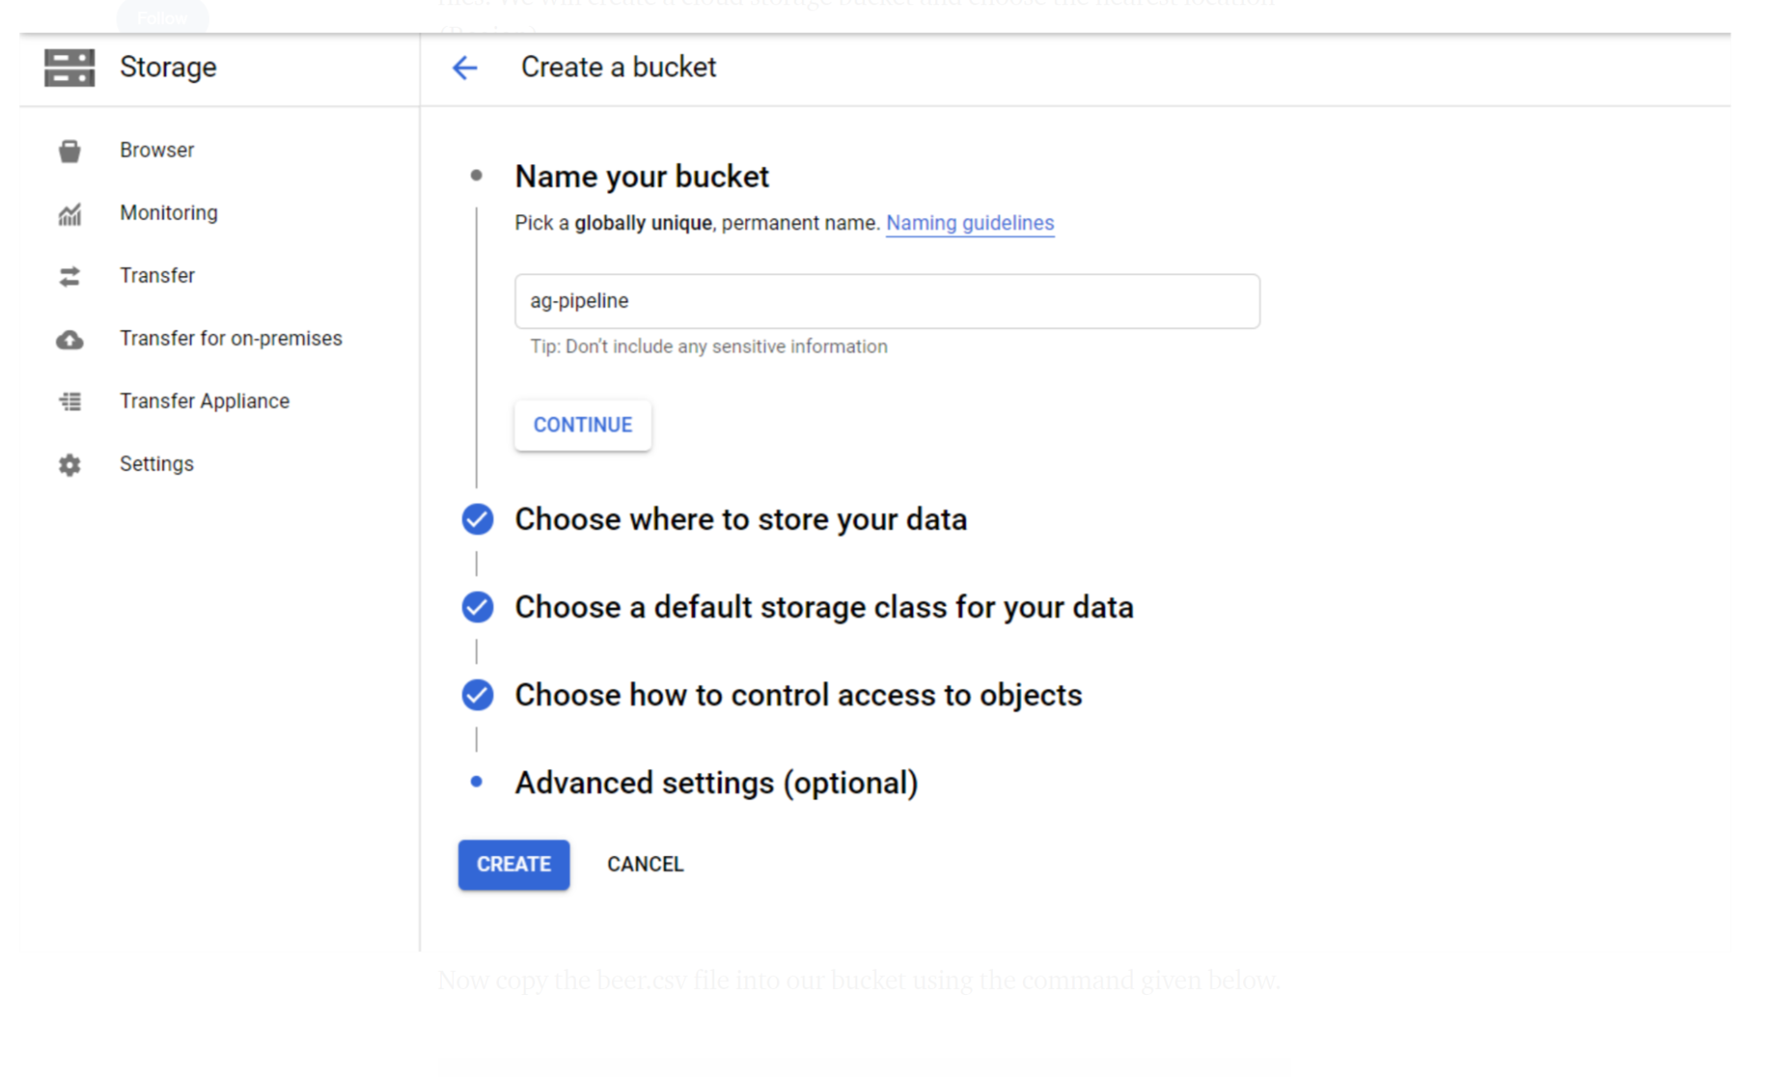

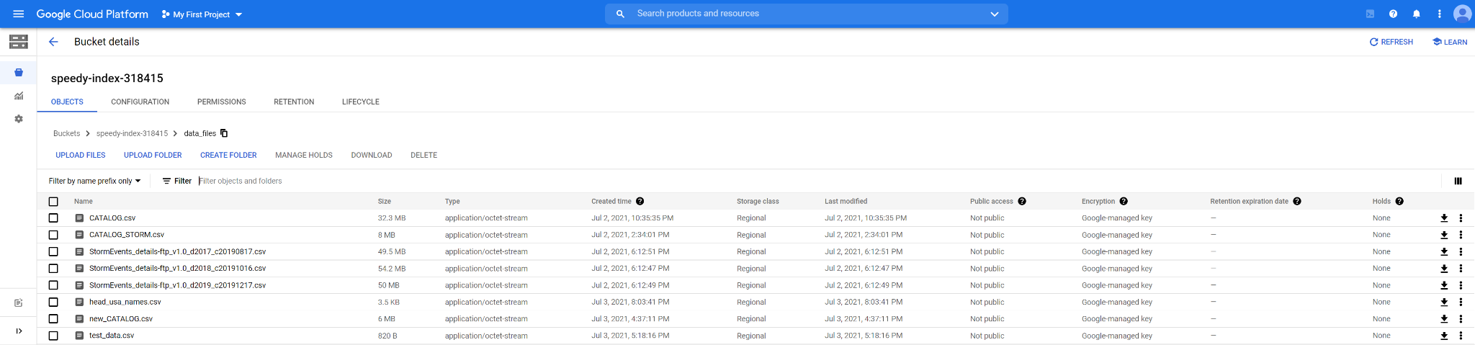

2. Created BigQuery dataset and table with the appropriate schema as a data sink -

where output from the dataflow job will reside in

**Ingestion Pipeline-**

This ingestion script holds the logic for transforming the file into a BigQuery table

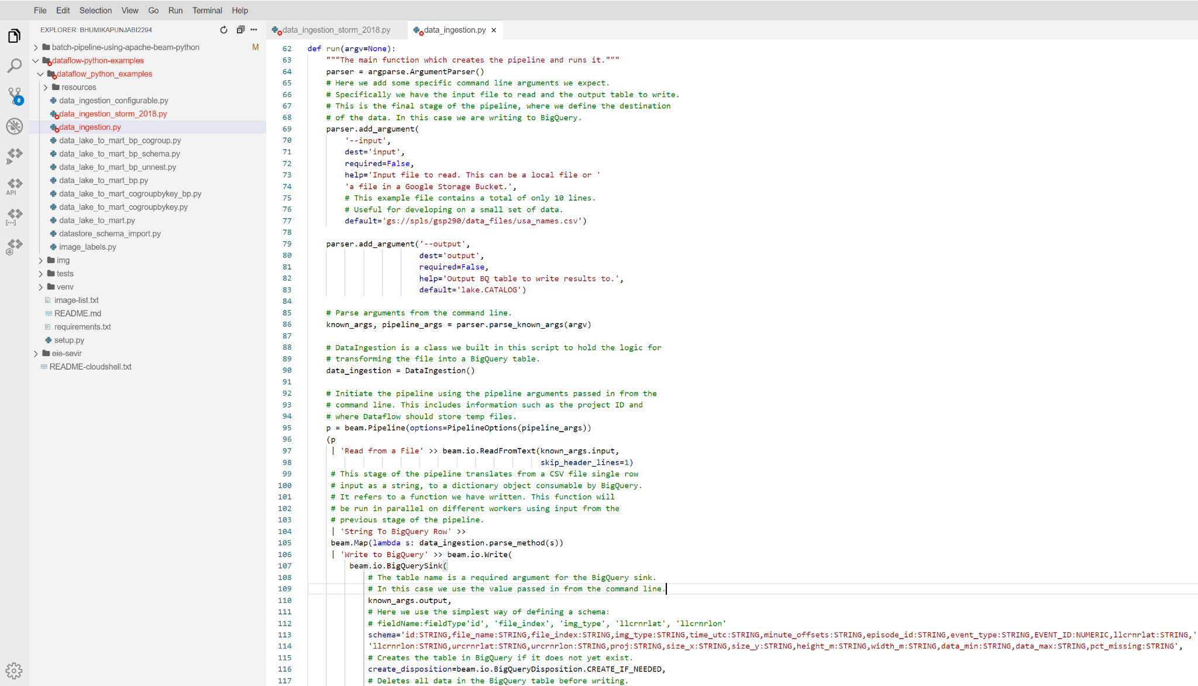

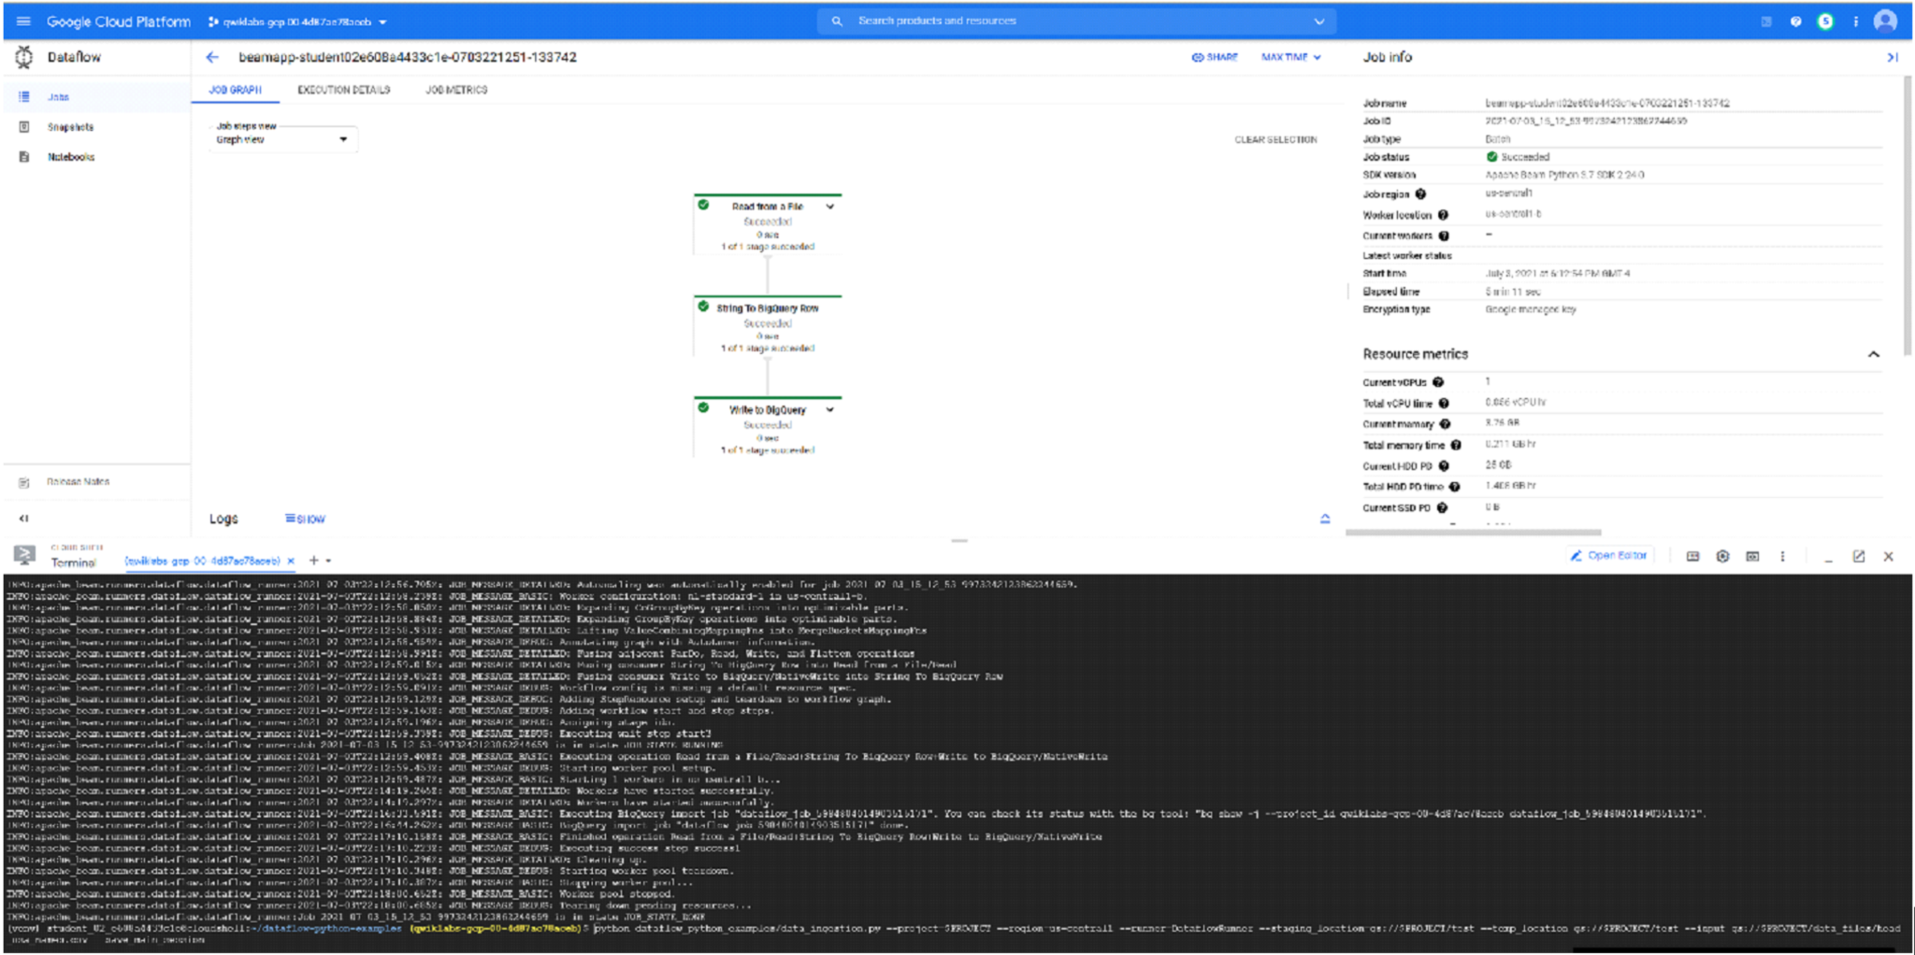

**Pipeline to join Bigquery tables-**

Using a composite transform to perform inner join on a column- EVENT_ID

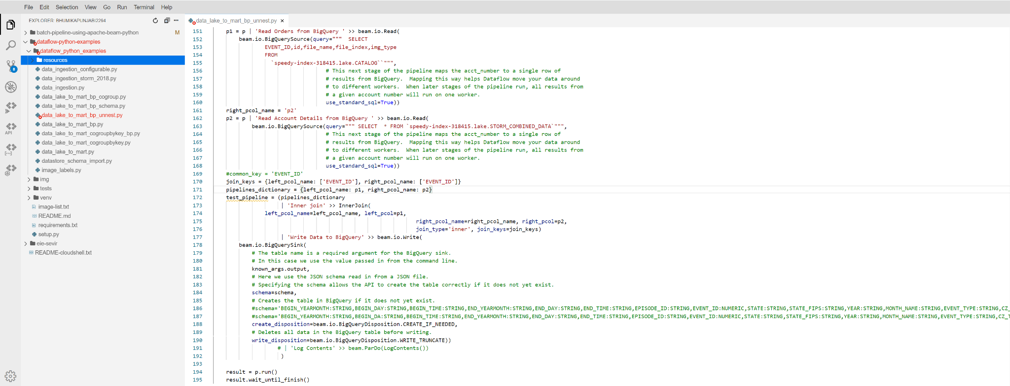

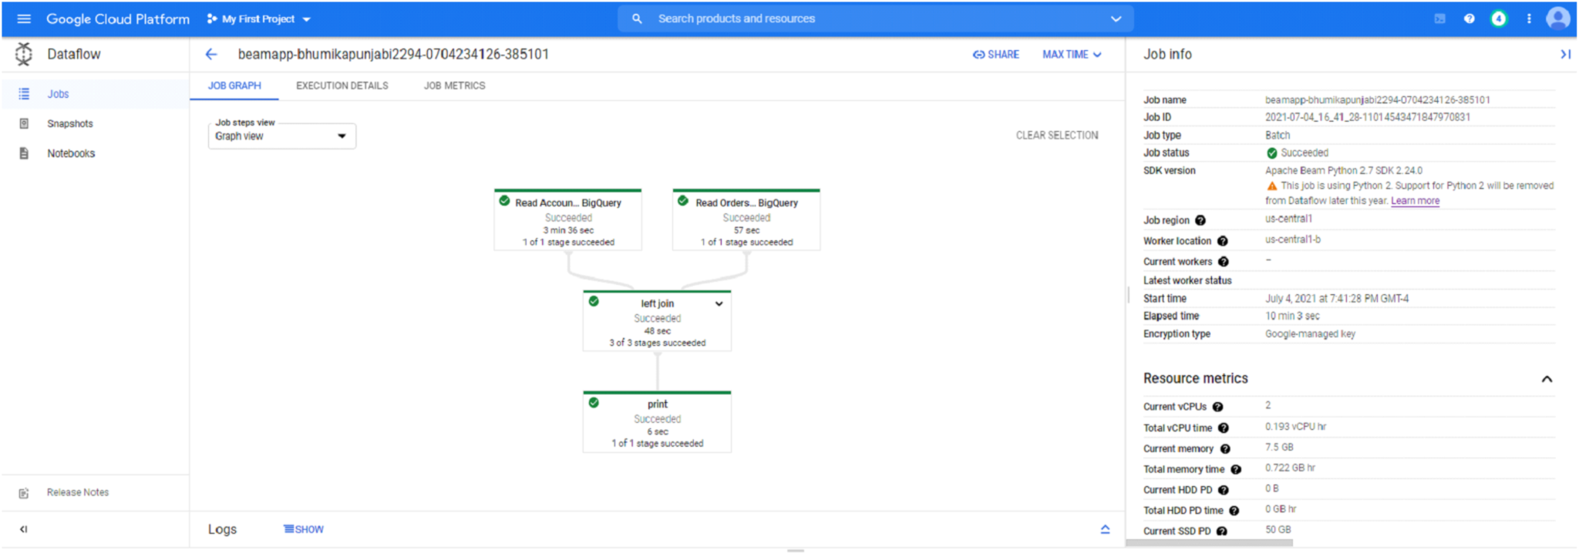

This is how the Dataflow DAG looks like on the GCP console on expanding the ‘Inner join’ transform-

* 1. Pre-processing the records to desired <K,V> value pairs, where key is a tuple of value(s) of column(s) you want to join and value being the entire record
* 2. CoGroupByKey transform
* 3. Transformation step to unnest the records using inner join

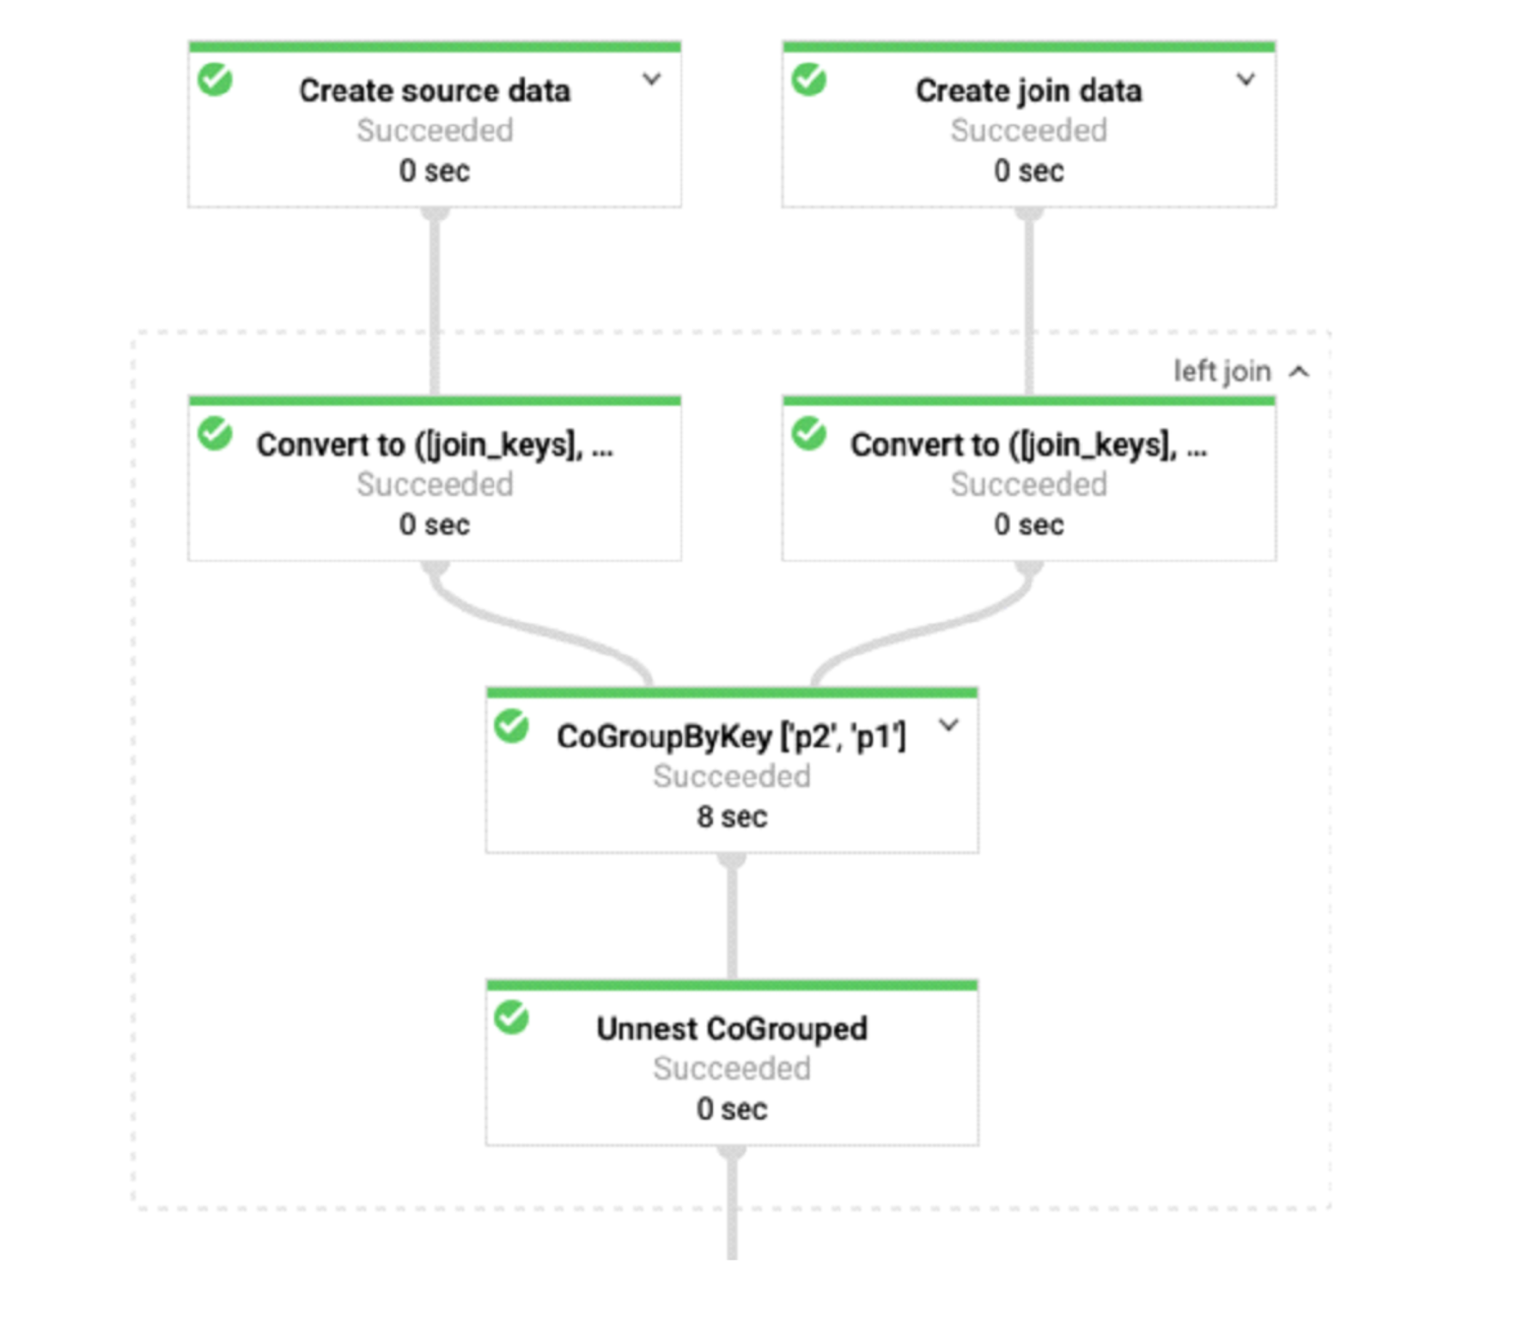

Dataflow logs(After running all pipelines)

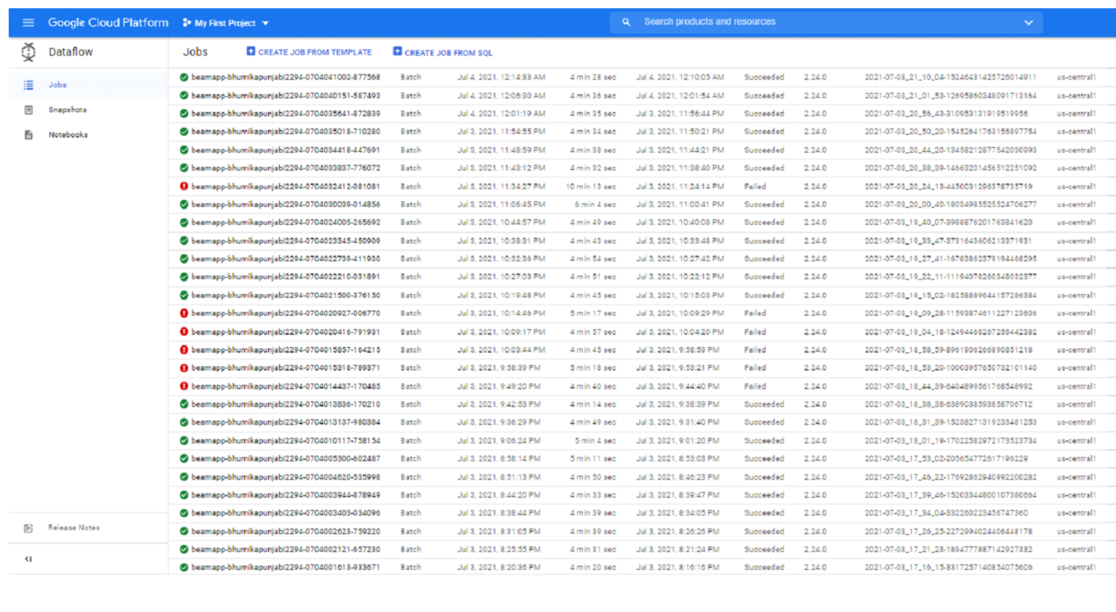

Once completed and succeeded, we can see results in the BigQuery

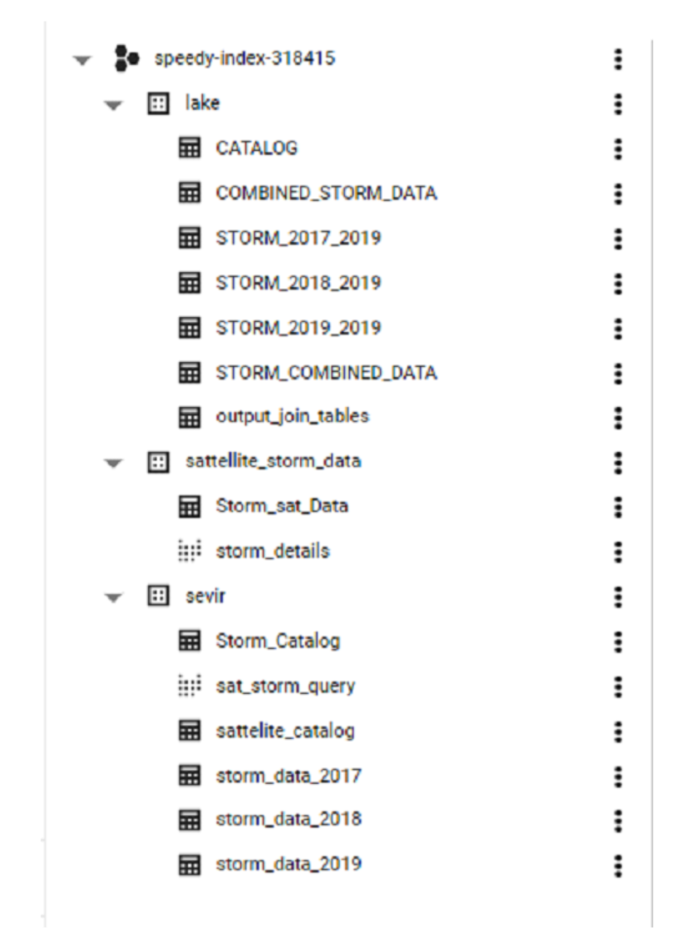

3. (Method2) Query and join the Bigquery tables to get some insights of output.

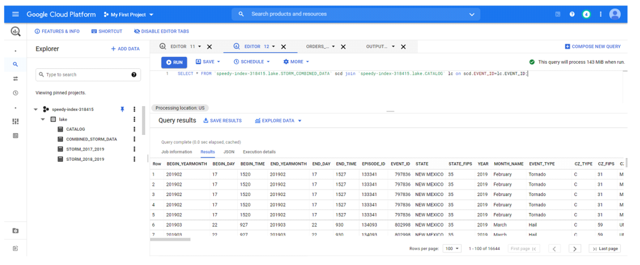

4. Visualizations using Data Studio

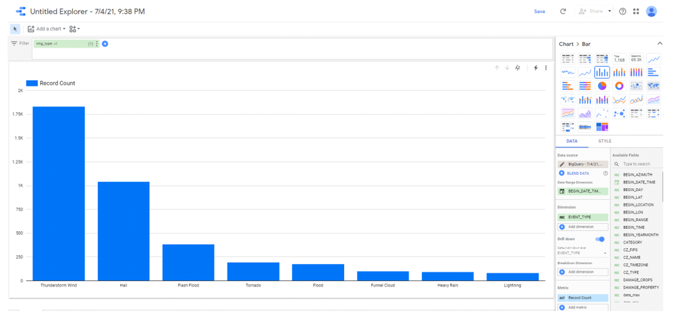

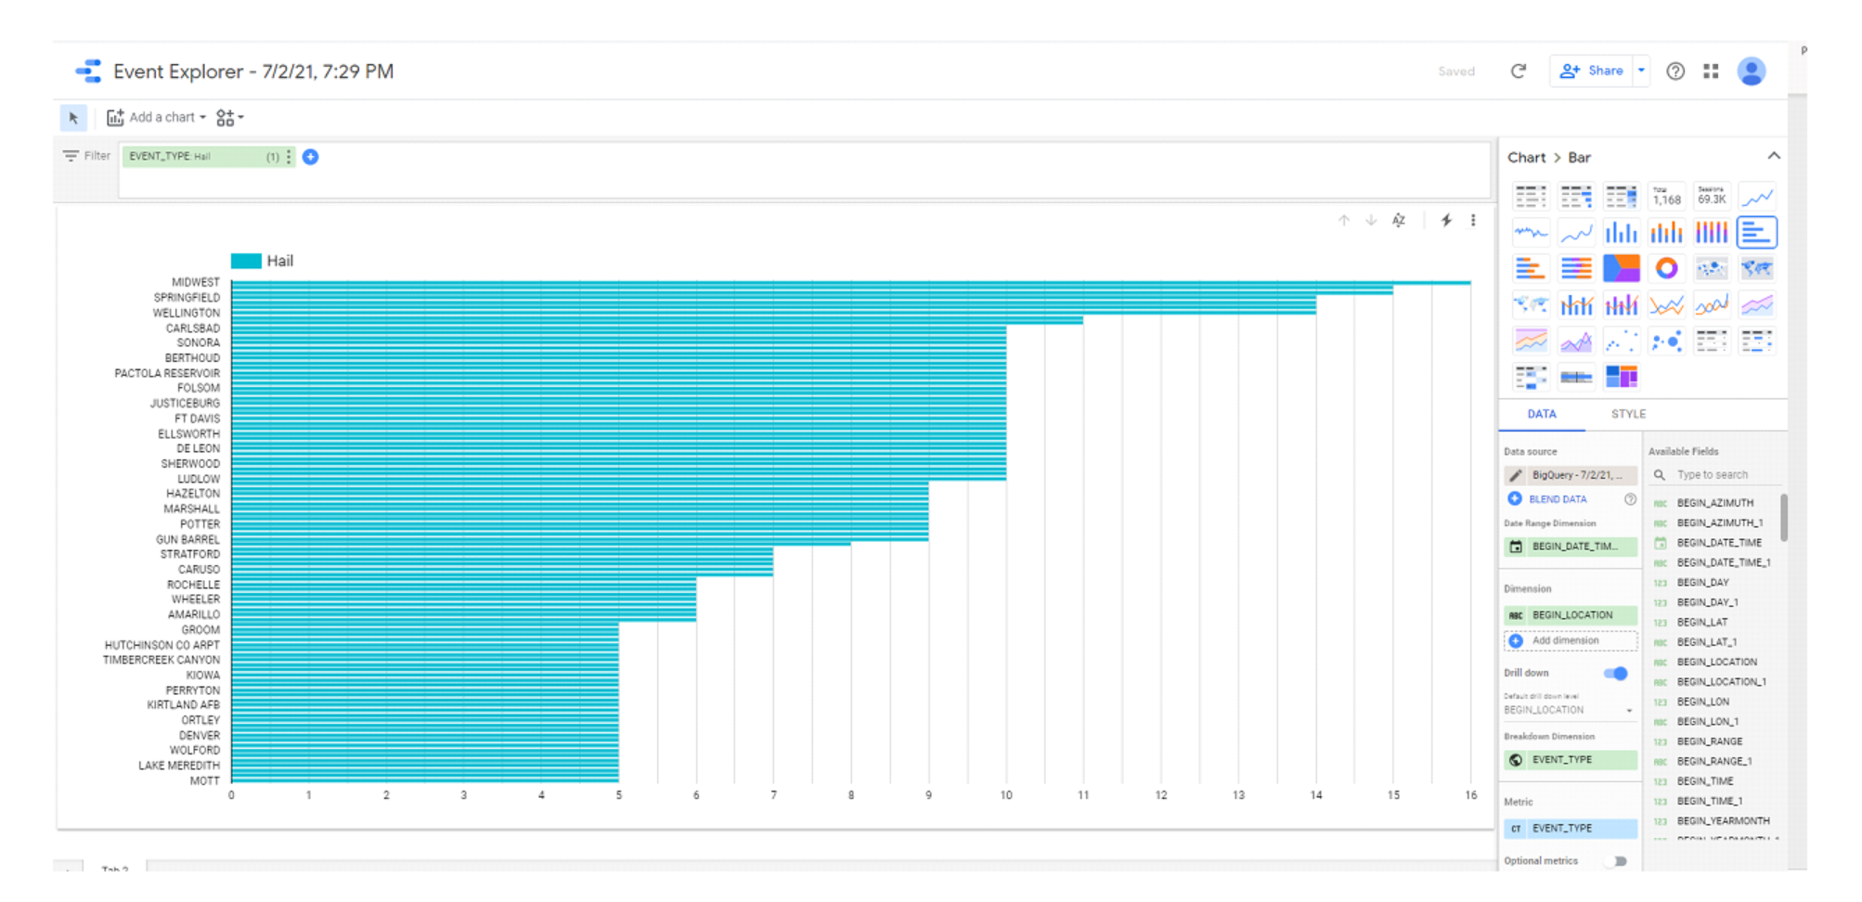

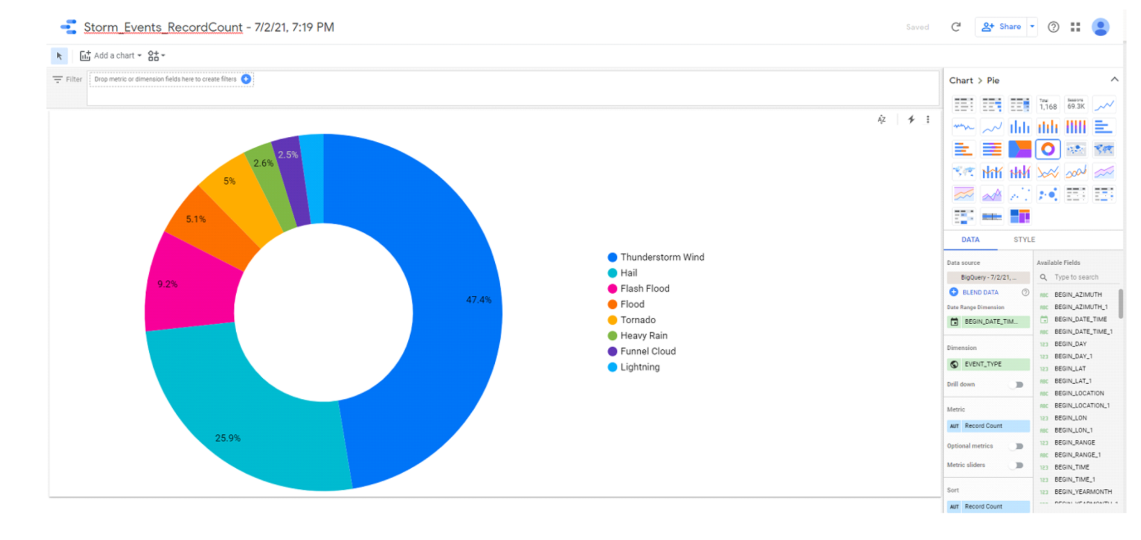

# Different Architecture

Preprocessing and Merging Data by creating Data pipeline using TRIFACTA -

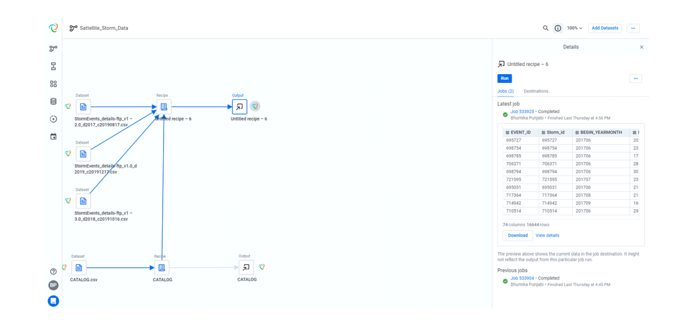

Preprocessing Recipes

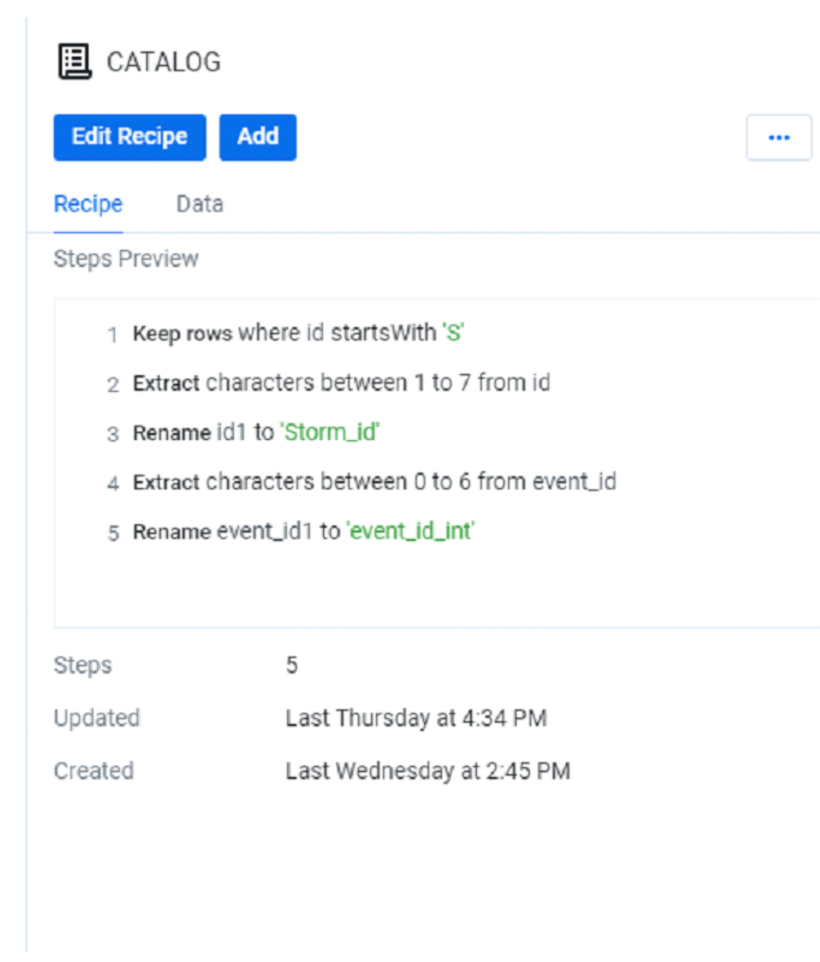

Recipe to join Data

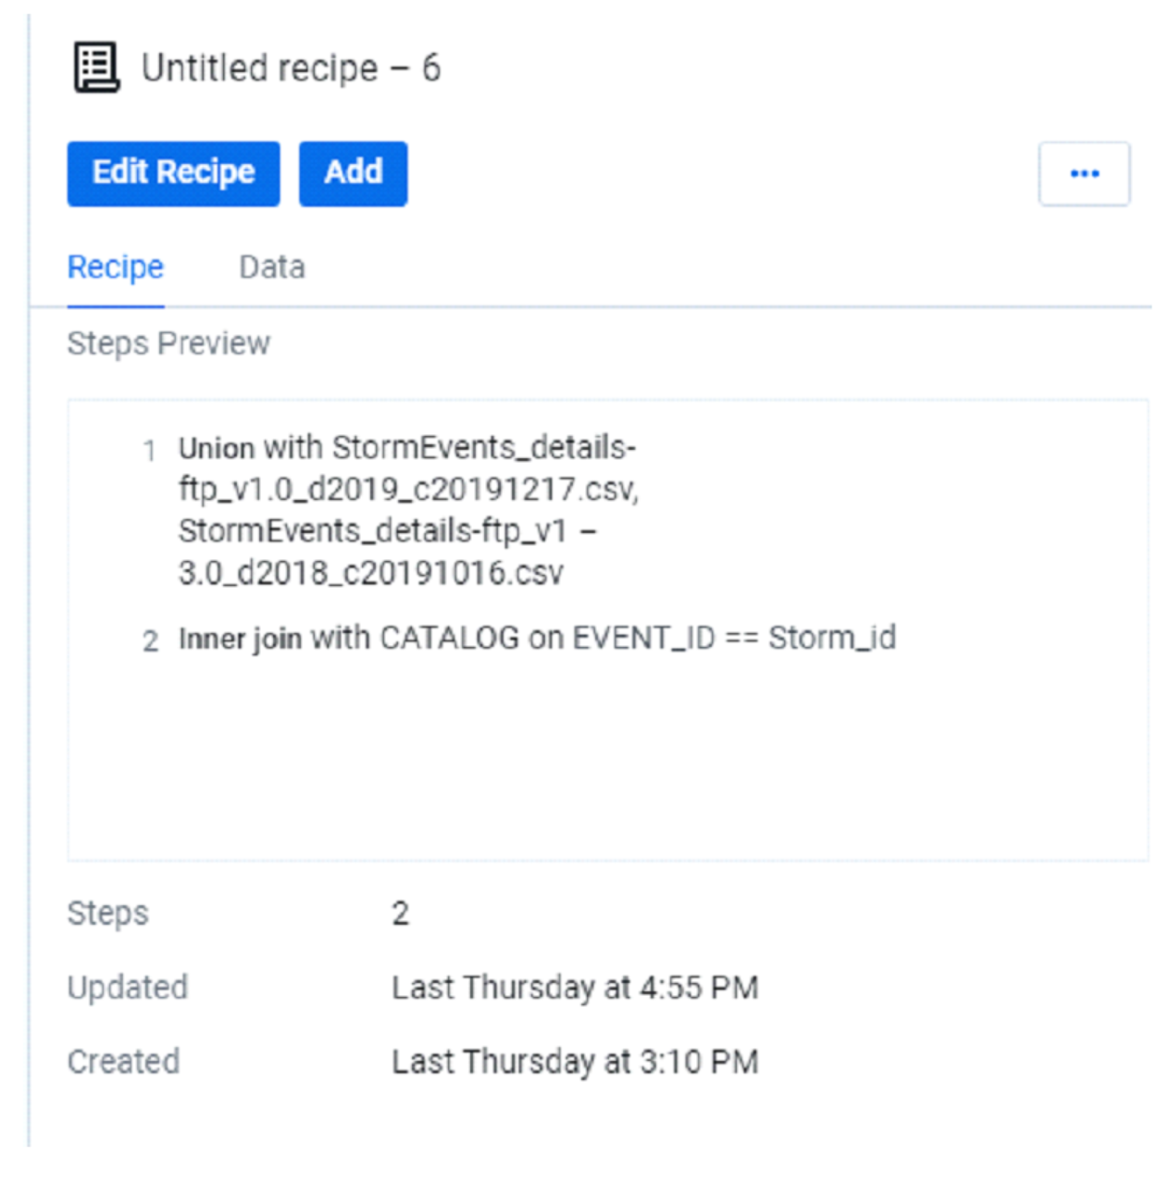

Uploading the output csv file to Bigquery and further doing data visualization-

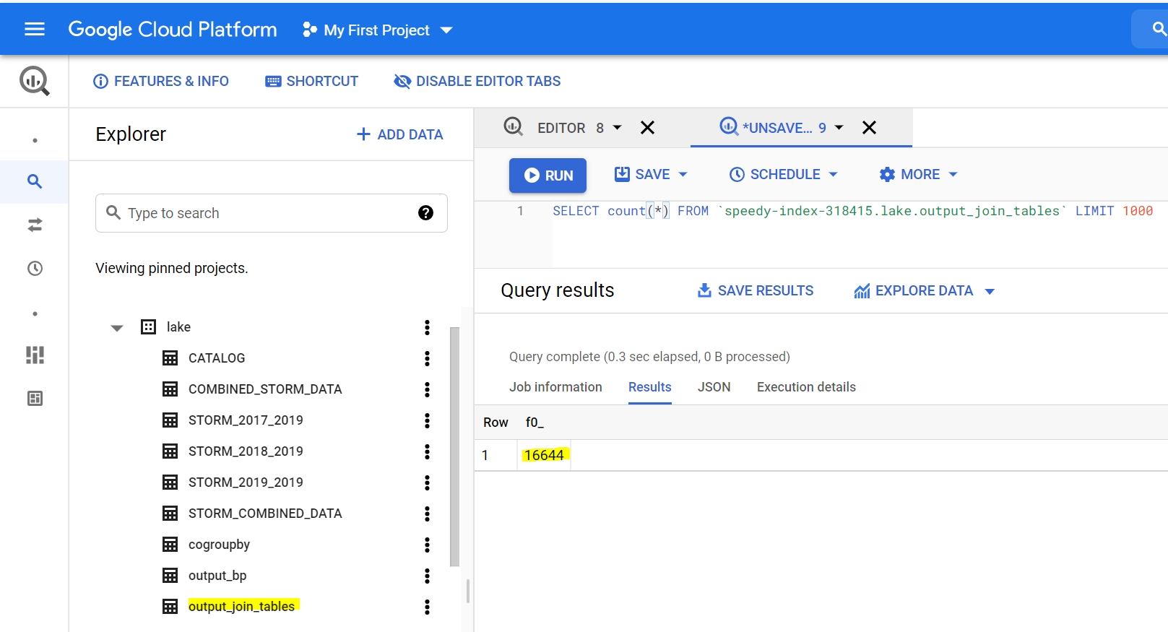

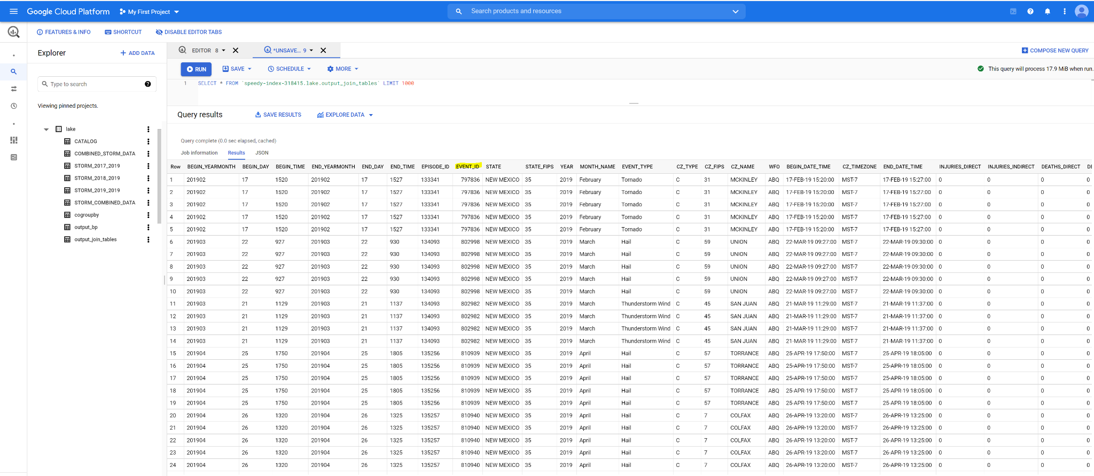

# Challenges

**Tool Based-**

Faced challenges while merging the Satellite and Storm Data, using Apache beam Dataflow pipeline at first,Hence did the Data wrangling and merging using TRIFACTA, which was a quick process, but later after getting insight of data, included data preprocessing steps in the Apache Dataflow pipeline

**Based on Performance and speed-**

Trifacta accelerates data cleaning & preparation with a modern platform for cloud data lakes & warehouses. Ensure the success of analytics, ML & data onboarding initiatives across any cloud, hybrid and multi-cloud environment.

Whereas, Apache Beam(Batch + Stream) is a unified programming model that defines and executes both batch and streaming data processing jobs. It provides SDKs for running data pipelines and runners for executing them on distributed processing backends, one of them is Google Cloud Dataflow has overall better Performance and speed

**Integrate different data sources**

Beam provides value in use cases that involve data movement from different storage layers, data transformations, and real-time data processing jobs better.